**Vivekanand Education Society’s** 

**Institute of Technology**

**(Affiliated to University of Mumbai, Approved by AICTE & Recognized by Govt. of Maharashtra)**

**Department of Information Technology**

A.Y. 22-23

MAD & PWA Lab

Journal

| Experiment No. | 01 |
| --- | --- |
| Experiment  Title. | To install and configure the Flutter Environment |
| Roll No. | 53 |
| Name | SAKSHI SANTOSH PATIL |
| Class | D15B |
| Subject | MAD & PWA Lab |
| Lab Outcome | LO2: Design and Develop interactive Flutter App by using widgets, layouts, gestures and animation |

Grade:

**AIM:** Installation and Configuration of Flutter Environment

**THEORY:**

Flutter is a mobile app development platform created by Google. It allows developers to create web and desktop apps that run on Android and iOS devices. The flutter development tools come with a graphics library and material design allowing faster operations of the app and also giving the app a stunning look, irrespective of its operating platform! The biggest advantage of flutter is that it can be used to create cross-platform apps. Using flutter one can create iOS and Android apps in just one go, there is no need to develop apps individually for both the platforms. Flutter uses a reactive programming language called Dart, making development faster and easier than traditional methods.

With powerful graphics and animation libraries, the Flutter framework makes it easy to build user interfaces that react smoothly in response to touch.

When creating a Flutter app, you'll be working with what's called a "widget." Widgets are the basic building blocks of a Flutter app, and they're used to create both the visual components of an app (like buttons and text) and the functional elements (like Stateless Widgets).

Features of Flutter:

1. Dart programming language: Flutter uses the Dart programming language, which is easy to learn and allows you to develop high-quality apps.
2. Hot reload: Flutter's "hot reload" feature lets you quickly and easily make changes to your app without restarting it.
3. Expressive and flexible UI: Flutter's UI elements are built using the same principles as Google's Material Design guidelines, giving you an expressive and flexible way to create beautiful apps.
4. Native performance: Flutter apps are compiled to native code, giving you the best possible performance on both iOS and Android.
5. Open source: Flutter is an open-source project, which means you can use it for free and contribute to the platform's development.

**IMPLEMENTATION:**

**Install the Flutter SDK**

**Step 1:** Download the installation bundle of the Flutter Software Development Kit for windows.

To download Flutter SDK, Go to its official website https://docs.flutter.dev/get-started/install ,

you will get the following screen.

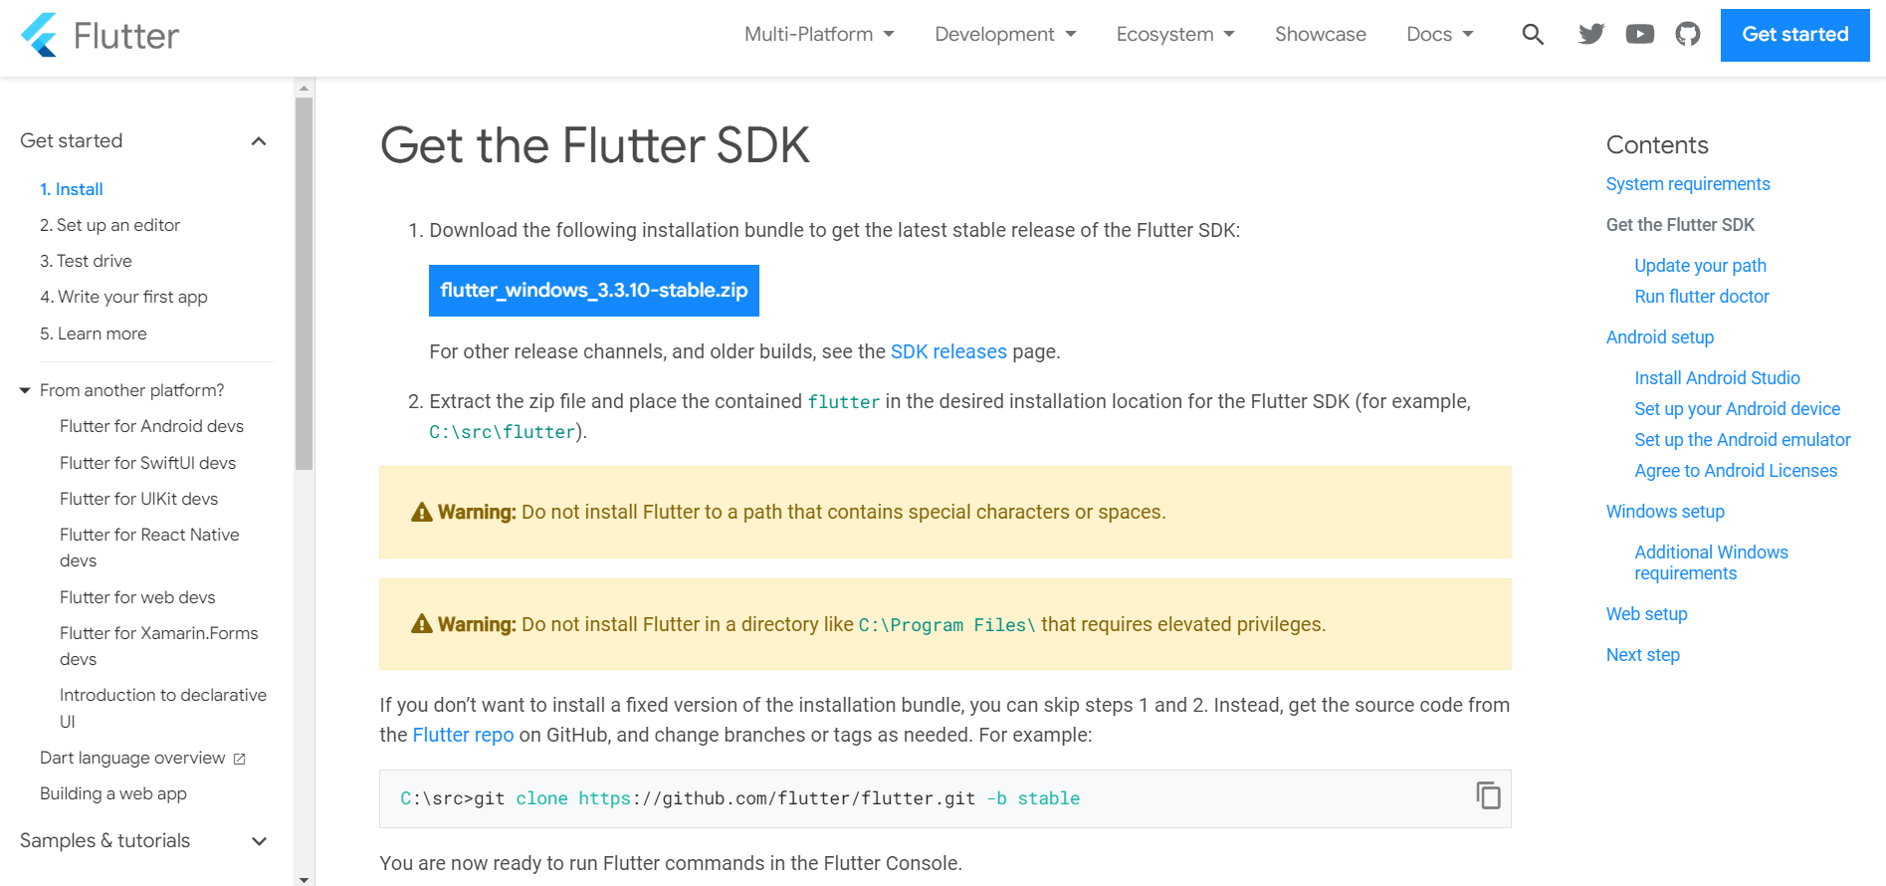

**Step 2:** Next, to download the latest Flutter SDK, click on the Windows icon. Here, you will

find the download link for SDK.

**Step 3:** When your download is complete, extract the zip file and place it in the desired

installation folder or location, for example, C: /Flutter.

**Step 4:** To run the Flutter command in regular windows console, you need to update the system

path to include the flutter bin directory. The following steps are required to do this:

**Step 4.1:** Go to MyComputer properties -> advanced tab -> environment variables. You will get the following screen.

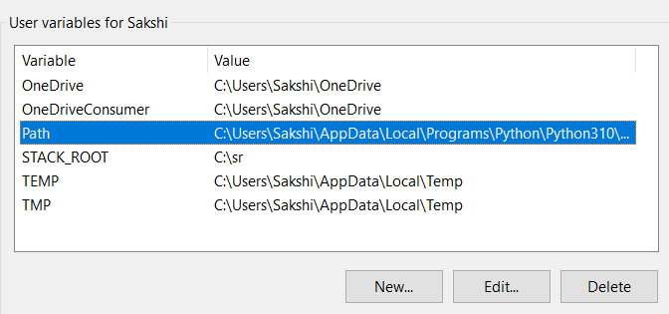

**Step 4.2:** Now, select path -> click on edit. On the screen that appears, click on New and Paste the flutter bin path.



**Step 5:** Now, run the $ flutter command in the command prompt.

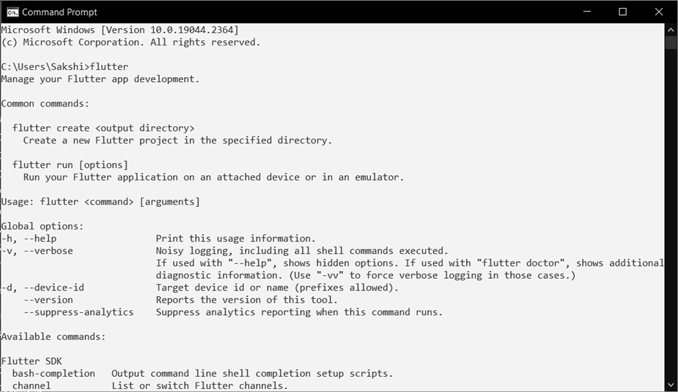

Now, run the $ flutter doctor command. This command checks for all the requirements of

Flutter app development and displays a report of the status of your Flutter installation.

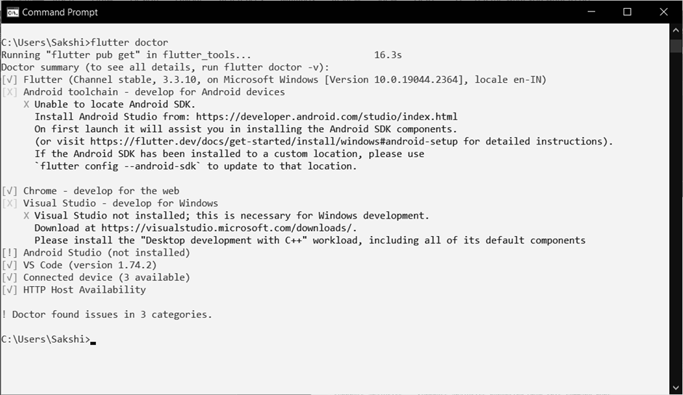

**Step 6:** When you run the above command, it will analyze the system and show its report, as

shown in the below image. Here, you will find the details of all missing tools, which required to

run Flutter as well as the development tools that are available but not connected with the device.

**Step 7:** Install the Android SDK. If the flutter doctor command does not find the Android SDK

tool in your system, then you need first to install the Android Studio IDE. To install Android

Studio IDE, do the following steps.

**Step 7.1:** Download the latest Android Studio executable or zip file from the official site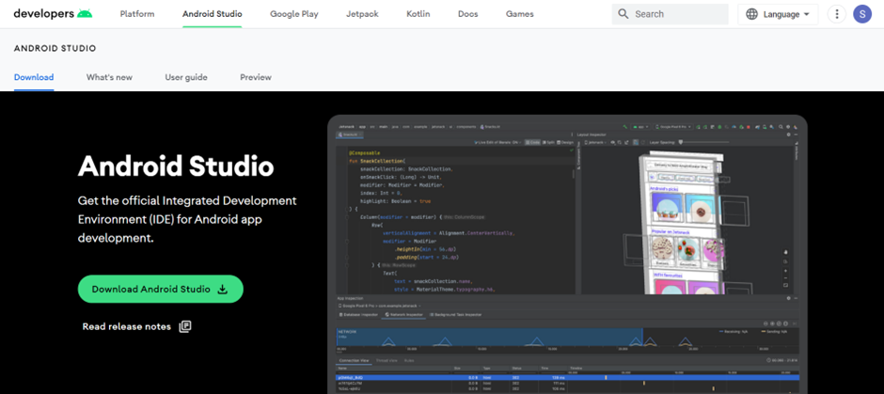

**Step 7.2:** When the download is complete, open the .exe file and run it. You will get the following dialog box.

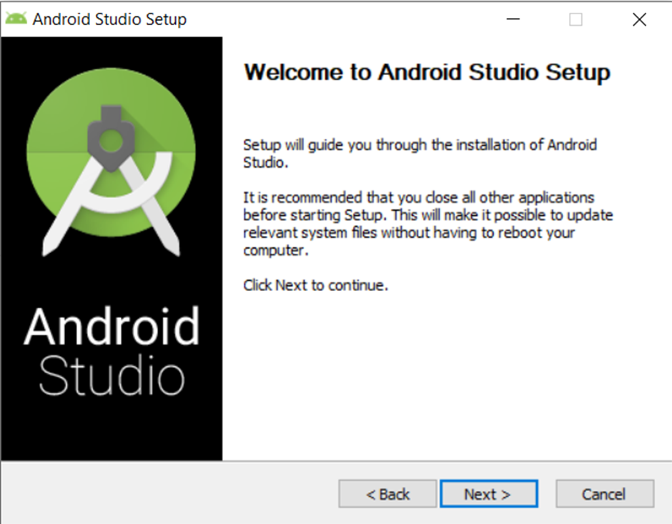

**Step 7.3:** Follow the steps of the installation wizard by keeping it to its default setting. Once the installation wizard completes, you will get the following screen.

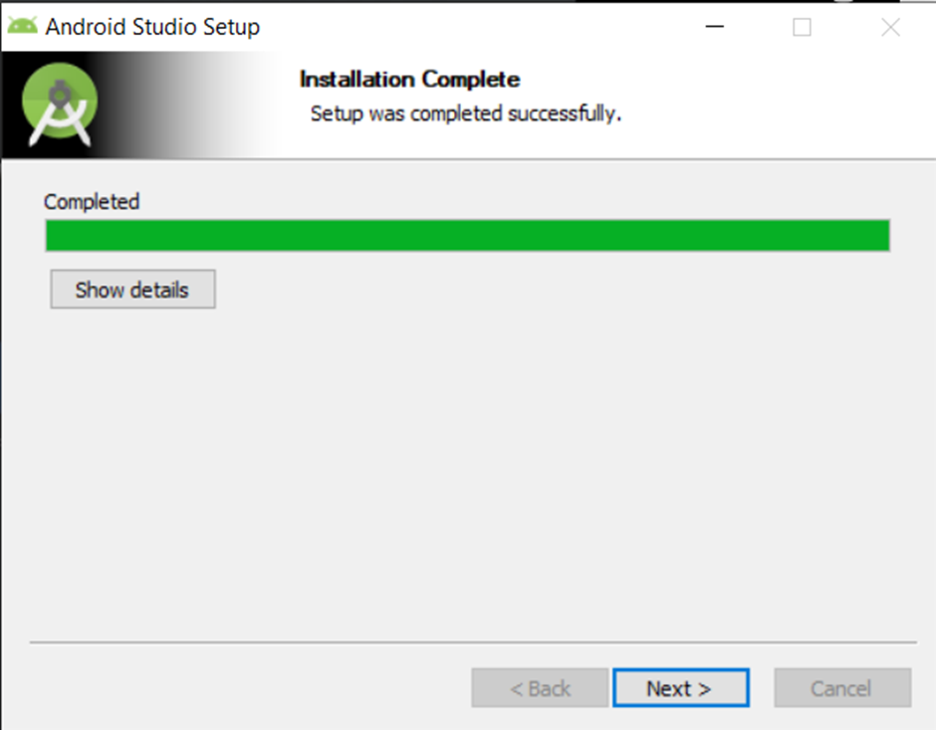

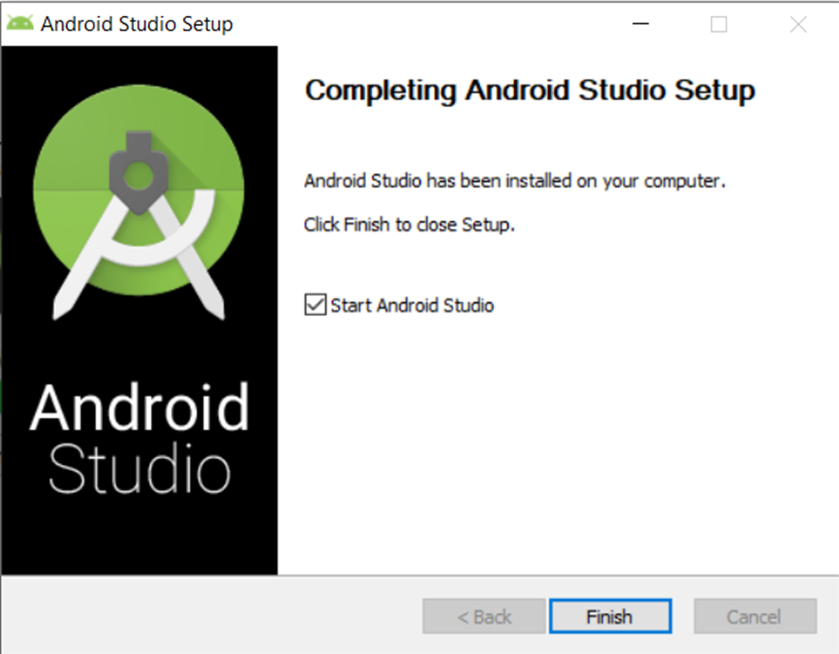

**Step 7.4:** In the above screen, click Next-> Finish. Once the Finish button is clicked, you need to choose the 'Don't import Settings option’ and click OK. It will start the Android Studio.

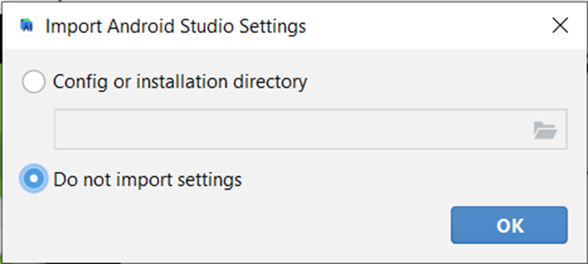

**Step 7.5:** Set the install type as ‘Standard’ and accept the License agreements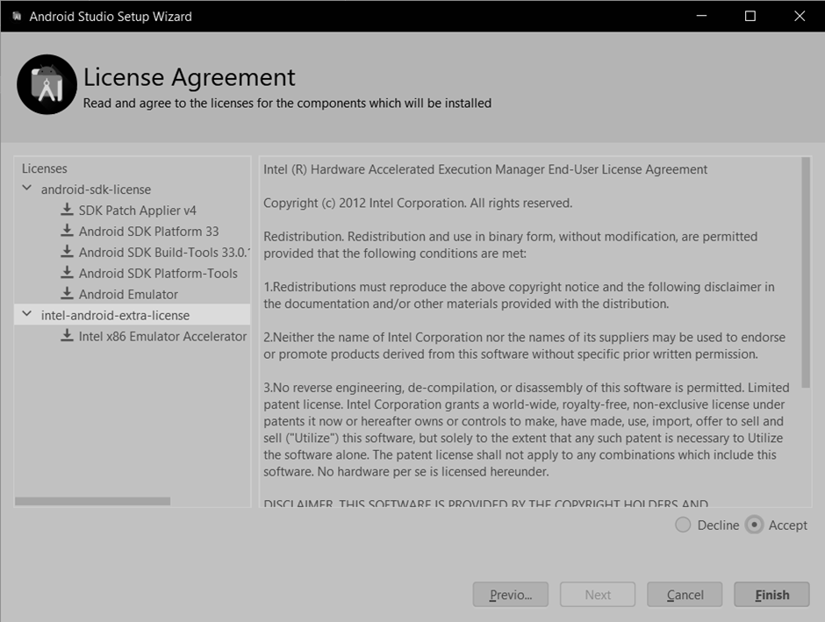

**Step 7.6:** It will start with the downloading of components and the application will start.

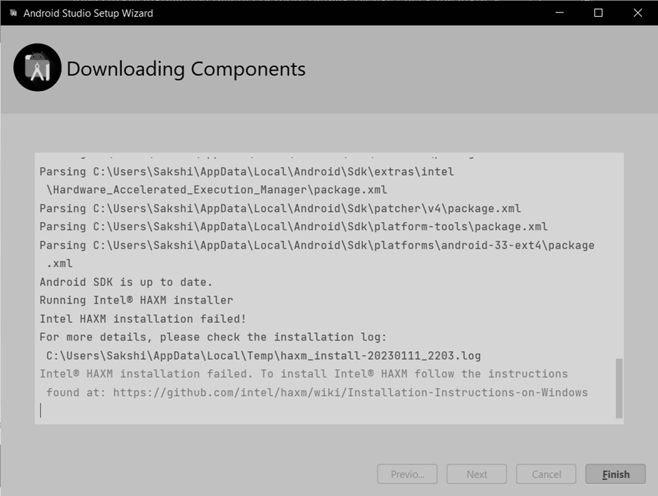

**Step 8:** Next, you need to set up an Android emulator. It is responsible for running and testing

the Flutter application.

**Step 8.1:** To set an Android emulator, go to Android Studio > Tools > Android > AVD Manager and select Create Virtual Device. Or, go to Help->Find Action->Type Emulator in the search box.

**Step 8.2:** Choose your device definition and click on Next.

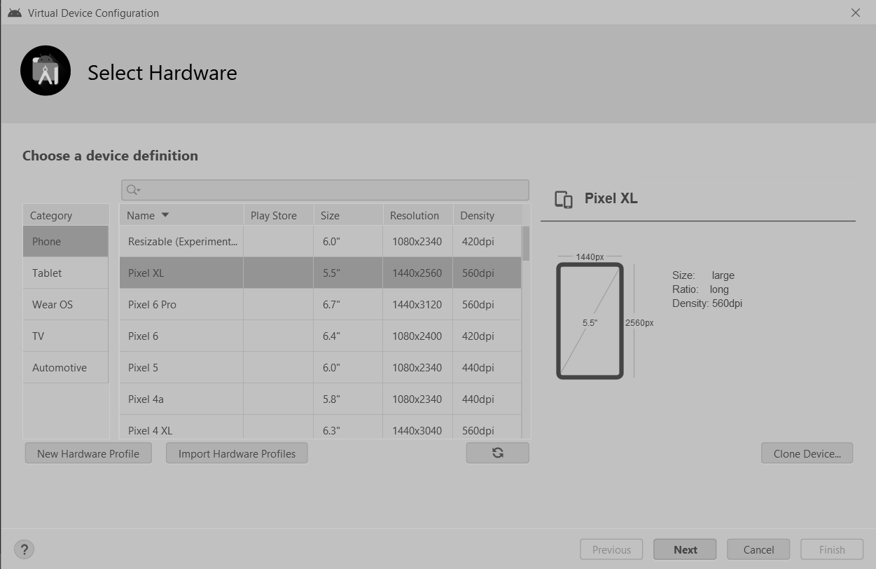

**Step 8.3:** Select the system image for the latest Android version and click on Next.

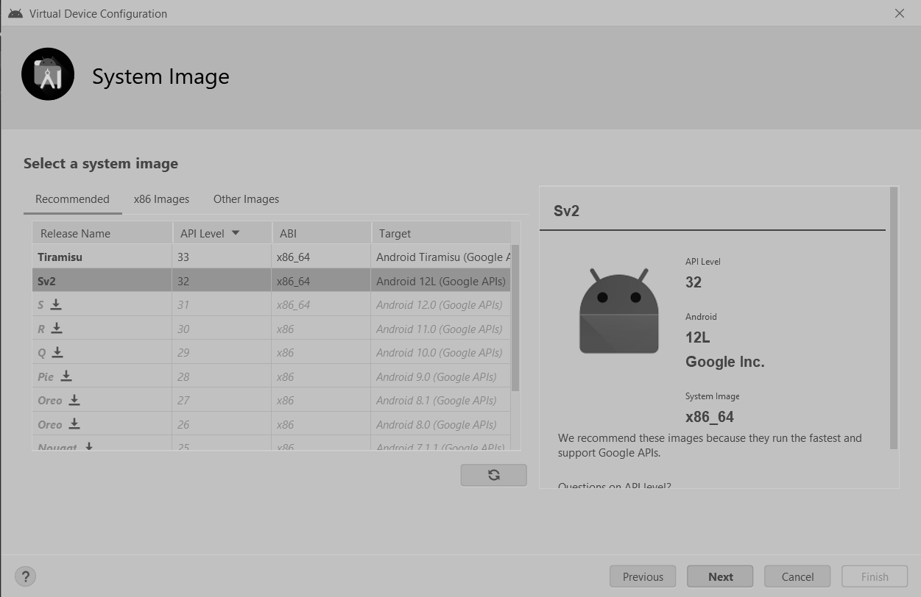

**Step 8.4:** Now, verify the all AVD configuration. If it is correct, click on Finish. The following screen appears.

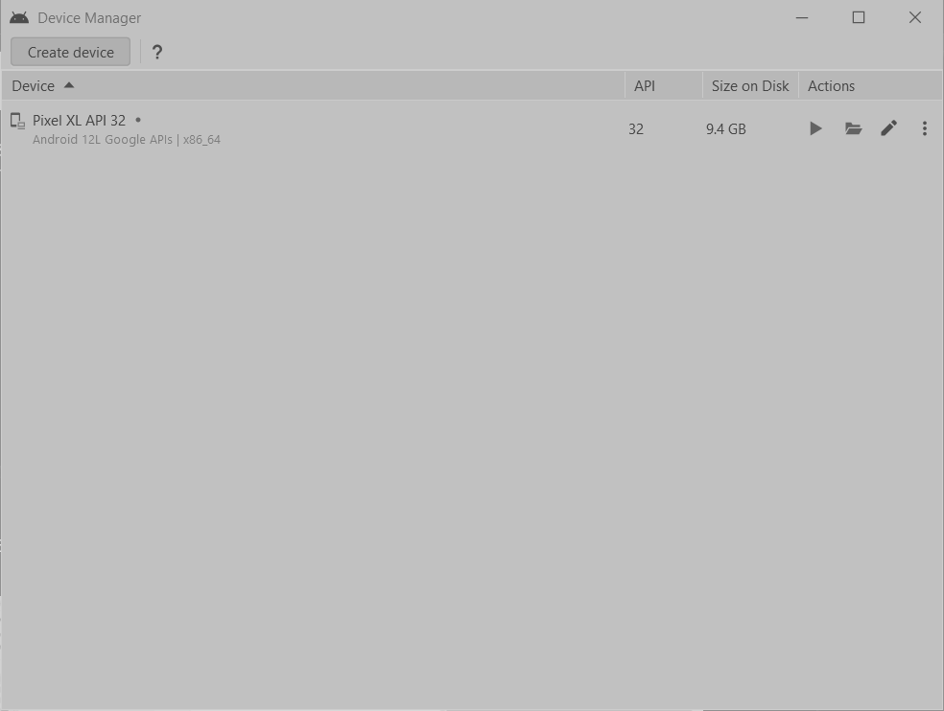

**Step 8.5:** Last, click on the icon pointed into the red color rectangle. The Android emulator displayed as shown below:

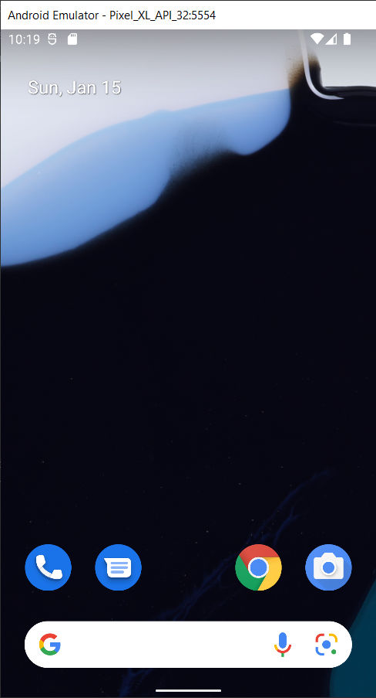

**Step 9:** Now, install the Flutter and Dart plugin for building Flutter applications in Android Studio.

These plugins provide a template to create a Flutter application, give an option to run and debug

Flutter application in the Android Studio itself. Do the following steps to install these plugins.

**Step 9.1:** Open the Android Studio and then go to File->Settings->Plugins.

**Step 9.2:** Now, search the Flutter plugin. If found, select Flutter plugin and click install. When you click on install, it will ask you to install the Dart plugin as shown below. Click yes to proceed.

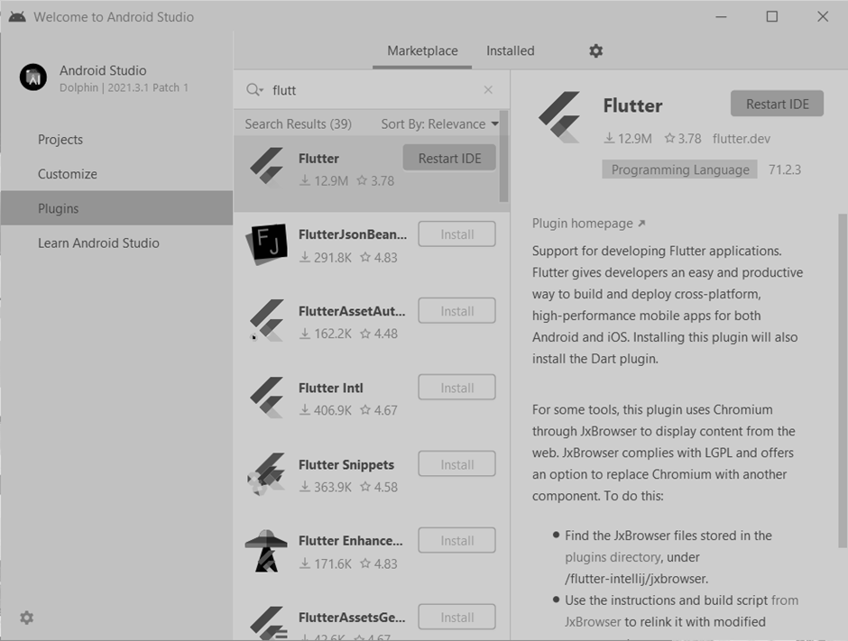

**Step 9.3:** Enter the command $ **flutter doctor** to check if all the required specifications are set.

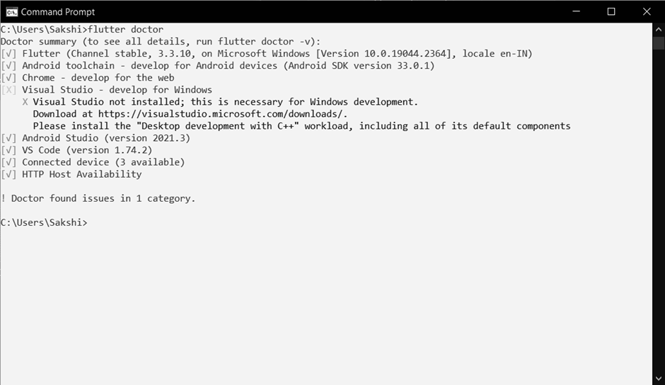

Step 10: Make sure the below settings are updated.

More Actions -> SDK Manager -> SDK Platforms

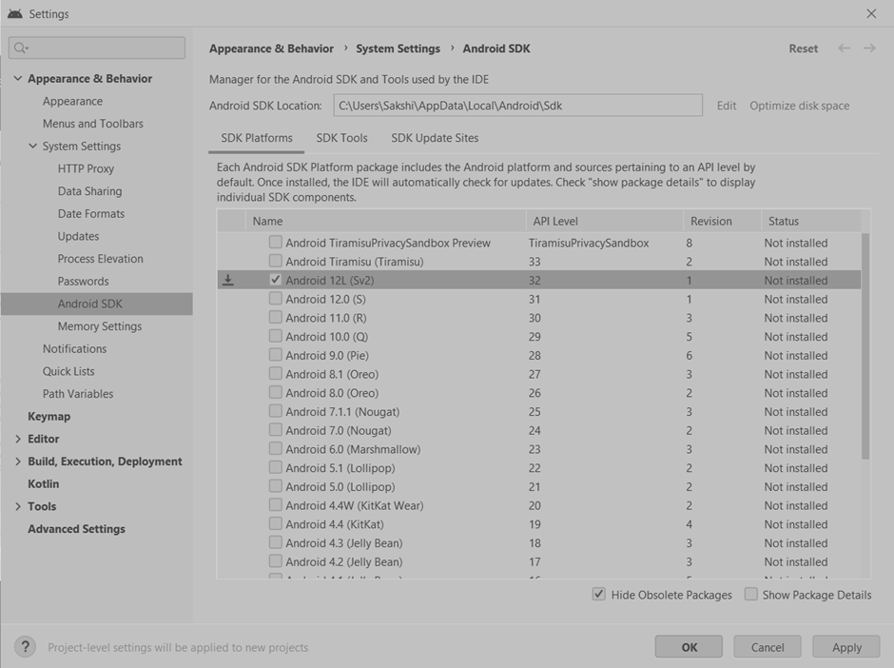

More Actions -> SDK Manager -> SDK Tools

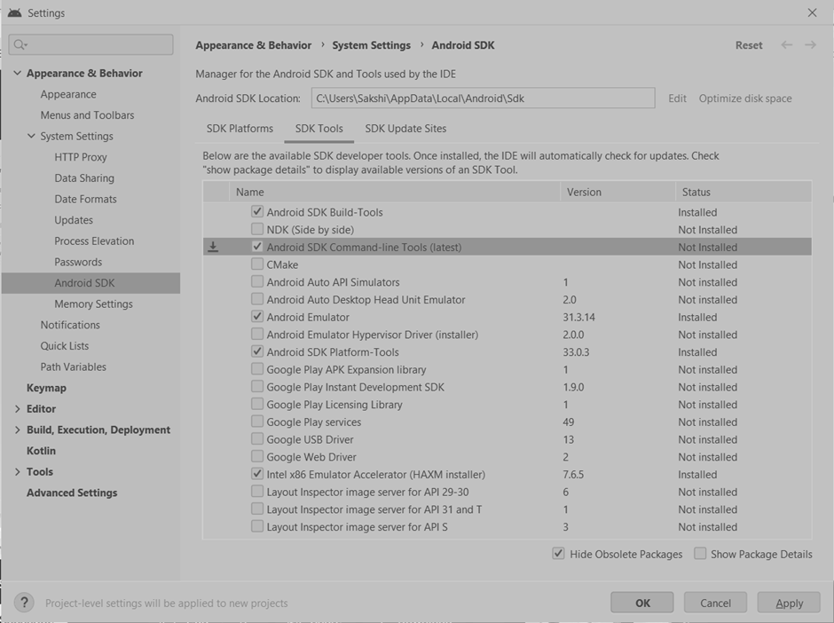

**Step 11:** Restart the Android Studio.

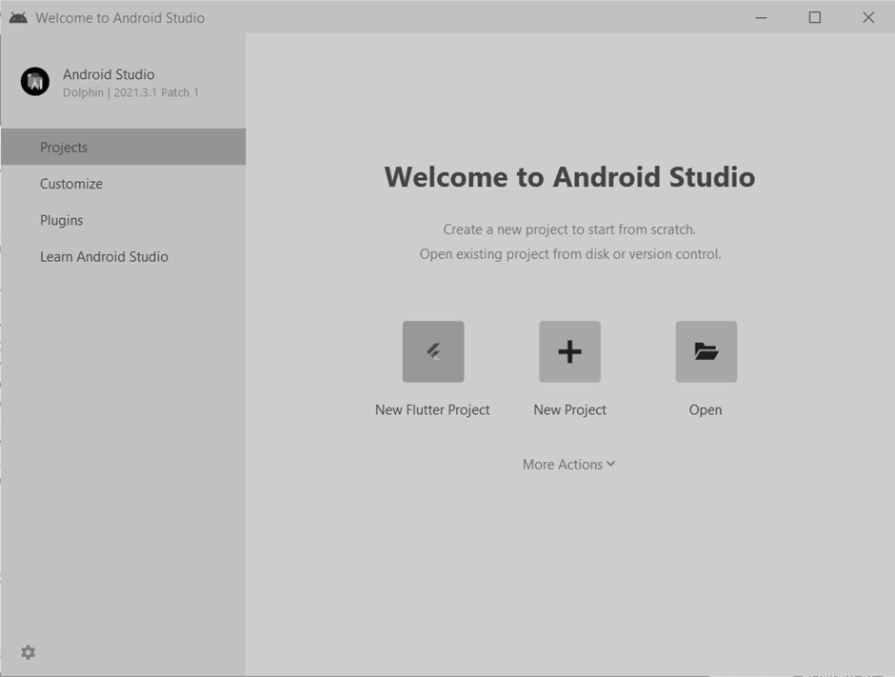

**CONCLUSION:**

We have successfully downloaded and installed Flutter. We have configured it according to the required settings.